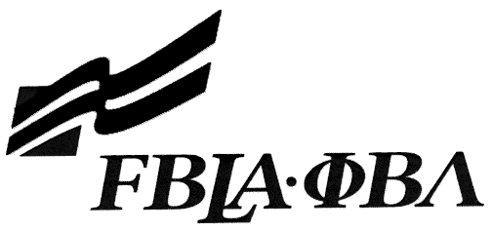

2017 PBL SLC IMPROMPTU SPEAKING
Preliminary Round Topic

Many students have part time jobs. What are the most important traits of a good employee?



2017 PBL SLC IMPROMPTU SPEAKING
Final Round Topic

A mission statement is a way of communicating the purpose of a person or organization. If you were to develop a mission statement, what would it be, and why?

